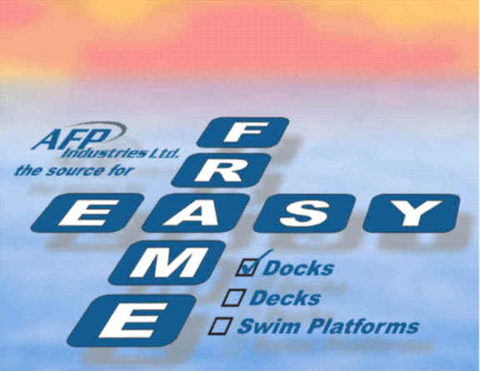

ASSEMBLY INSTRUCTIONS

PARTS LIST
Basic Dock Kit
Part Quantity Description
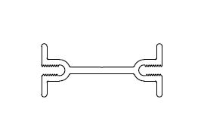
A1 3 Deck Stiffener @ 120”
A2 4 Mitered Corner Stiffener @ 18”
B2 2 End Beam @ 59”
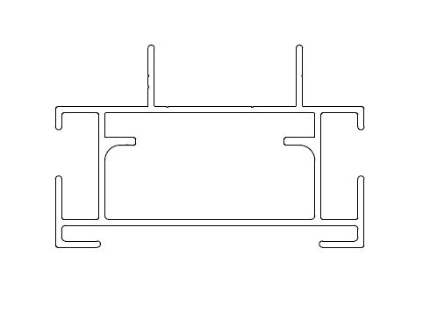
B1 2 Side Beam @ 120”
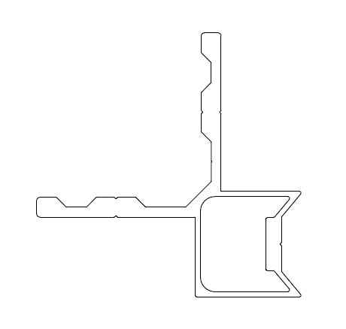
C 4 90° Beam Connector @ 6”
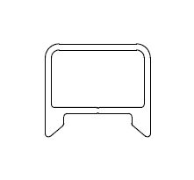
D1 2 Dock Leg @ 96”


E1 2 Removable Foot
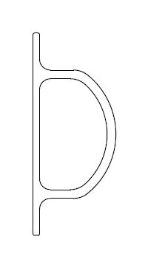
F1 2 Side Beam Bumper @ 120”
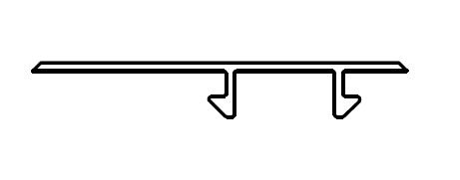
G1 2 Side Beam Top Cap @ 120”
G2 2 End Beam Top Cap @ 60”

**Starter kit comes with the purchase of first dock kit and includes;

D2 2 Dock Legs for fixing at shoreline @ 24”
E2 2 Removable Foot
F2 2 End Beam Bumper @ 60”
** Joiner kit supplied with multi-section installations – see page 7

ASSEMBLY OVERVIEW

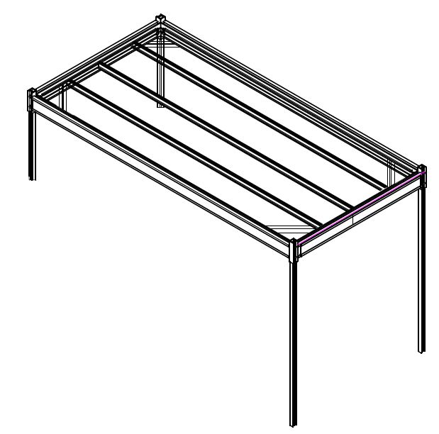
D1
D2
B1
B2
A1
A2
C
NOTE: LEGS SHOULD BE NO MORE THAN 60” BELOW FRAME.
SEE PG 7 FOR INSTRUCTIONS ON JOINING MULTIPLE DOCK SECTIONS.

STEP BY STEP INSTRUCTIONS

- LAY ALL PARTS OUT AND IDENTIFY
- DECIDE ON WHAT TYPE OF DECKING MATERIAL YOU ARE GOING TO USE. THE EASY FRAME IS MADE FOR EITHER 2” OR 5/4” BOARDS. ONCE THAT DECISION IS MADE, LAY PART B2 WITH THE PROPER LEG SHOWING (SEE DIAG 1)

DIAG 1:
Use this face up with the two lines for 2" material

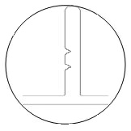
 |  | Use this face up with the one line for 5/4” material
 |  | 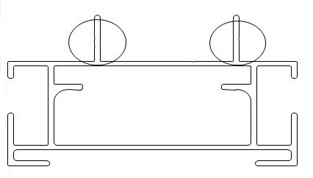 | 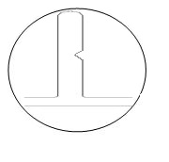

- TAKE PART B2 AND INSERT CORNER “E” IN EACH END AND SECURE WITH FASTENERS PROVIDED.

- REPEAT WITH SECOND PIECE OF B2.

- INSERT THE B2 END ASSEMBLIES INTO THE B1 SIDE FRAME. SECURE WITH FASTENERS PROVIDED (SEE DIAG 2)

DIAG 2:
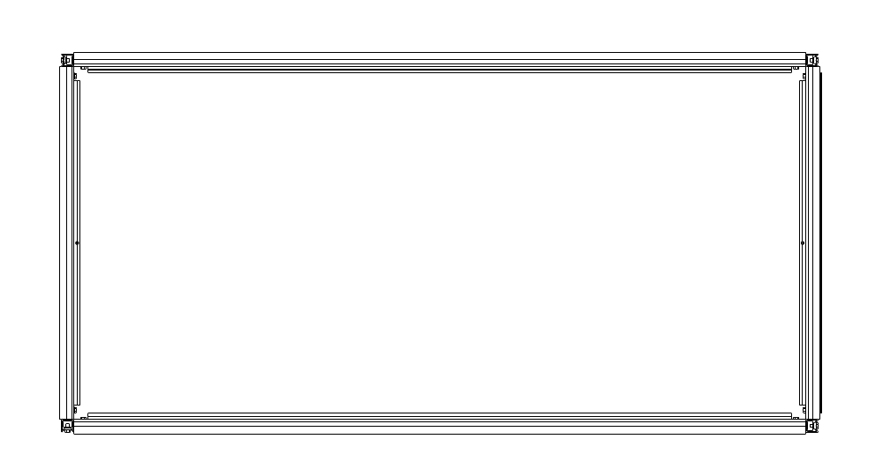

- INSERT STIFFENER A2 INTO CORNER AT PRE-DRILLED LOCATIONS USING FASTENERS PROVIDED ON TOP AND BOTTOM
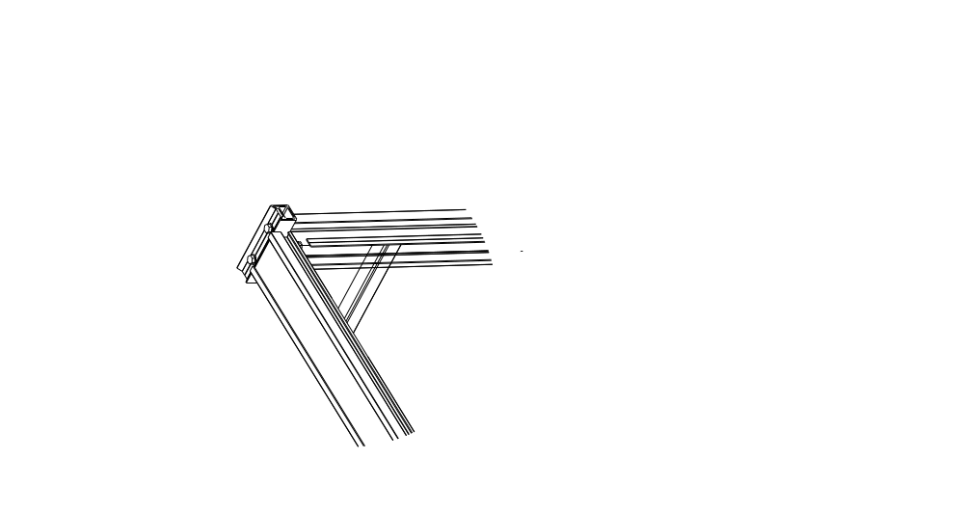

- REPEAT STEP 6 IN EACH CORNER.

- INSERT STIFFENER A1 INTO PRE-DRILLED LOCATIONS ON END RAIL B2 USING FASTENERS PROVIDED ON TOP AND BOTTOM

- REPEAT STEP 8 IN ALL THREE LOCATIONS
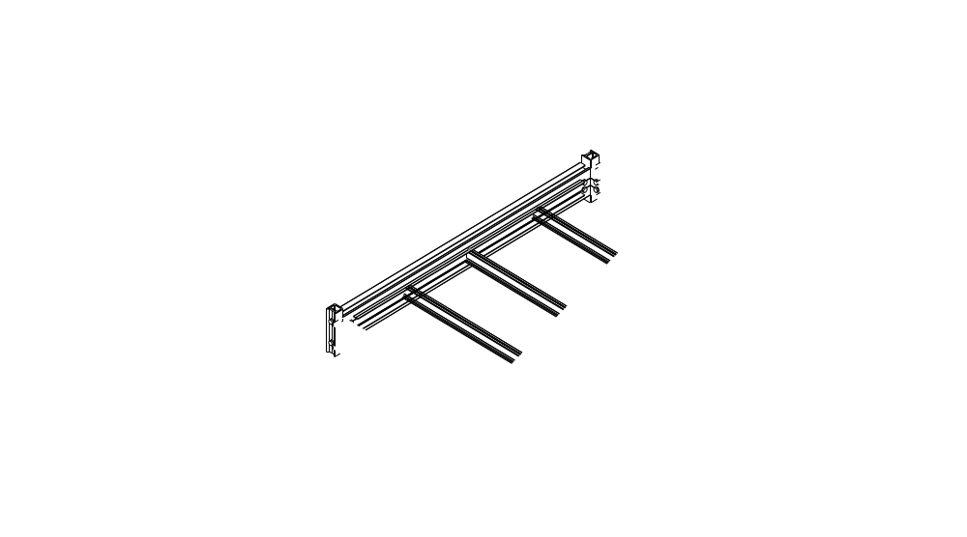
- INSERT POSTS “D1,D2” AND LOOSELY SECURE WITH 2 BOLTS
PROVIDED THROUGH CORNER “C”

**Note 24” legs and 60” bumper are provided in the Starter Dock Kit.
After that they are no longer required and not supplied.

- SLIDE IN BUMPERS AND SNAP IN TOP CAPS AND POST CAPS TO COMPLETE ASSEMBLY. THIS IS CRITICAL AS INJURY CAN OCCUR IF NOT PROPERLY INSTALLED.
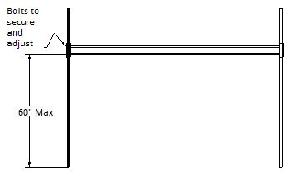
- USING TWO PEOPLE TAKE ASSEMBLED DOCK TO FINAL LOCATION

- ONCE YOU HAVE ESTABLISHED YOUR DESIRED LEVEL FOR YOUR
EASY FRAME DOCK, SECURE THE BOLTS THAT YOU ATTACHED IN STEP 10. NO MORE THAN 60” IS RECOMMENED TO BE BELOW THE FRAME LINE.

- EXCESS POST MATERIAL CAN BE CUT OFF BUT BE AWARE OF RISING AND LOWERING WATER LEVELS.

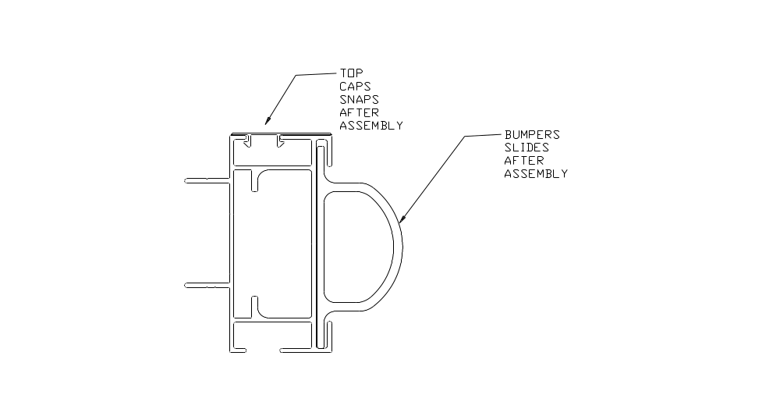
G1, G2
F1, F2

CONGRATULATIONS YOU HAVE NOW ASSEMBLED YOUR “EASY FRAME DOCK”

JOINING MULTIPLE DOCK SECTIONS

WITH EACH ADDITIONAL DOCK SECTION YOU WILL RECEIVE A SET OF JOINERS.
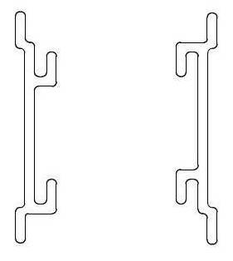
- ON EXISTING SECTION, DOCK SECTION (A) INSERT ONE JOINER EXTRUSION FROM EACH END, 12 INCHES, AND SECURE WITH SUPPLIED BOLT. MAKE SURE THAT THE LEGS OF THE JOINER OPEN UP AS SHOWN.
- ON THE SECTION TO BE ATTACHED, DOCK SECTION (B), INSERT ONE JOINER, THE SAME DISTANCE FROM EACH END AS SECTION (A), 12 INCHES, AND SECURE WITH SUPPLIED BOLT. MAKE SURE THAT THE LEGS OF THE JOINER OPEN DOWN AS SHOWN.

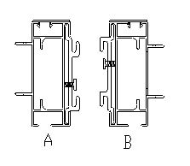
- OFFSET DOCK B, UP AND OVER APPROX. 3 INCHES TO CLEAR SECURING BOLTS.

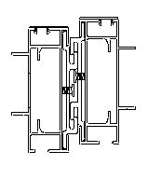
- DROP DOCK SECTION (B) INTO POSITION WITH DOCK SECTION (A) AND SLIDE DOCK SECTION (B) TO ALIGN WITH DOCK SECTION (A). CONFIRM THAT THE BOLTS HAVE ENGAGED TO NOT ALLOW THE DOCKS TO COME APART BY LIFTING UP ON DOCK SECTION (B).

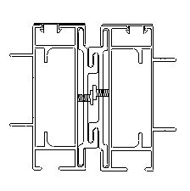

DECKING INSTRUCTIONS

- AFTER ASSEMBLY LAY DECKING GOOD FACE DOWN AND CALCULATE DESIRED SPACING.
- REMEMBER TO ALLOW FOR EXPANSION AND CONTRACTION.
- DIVIDE TOTAL AMOUNT OF DECK BOARDS USED BY 2 TO MAKE 2 INDIVIDUAL PLATFORMS. ( SEE DIAGRAM )
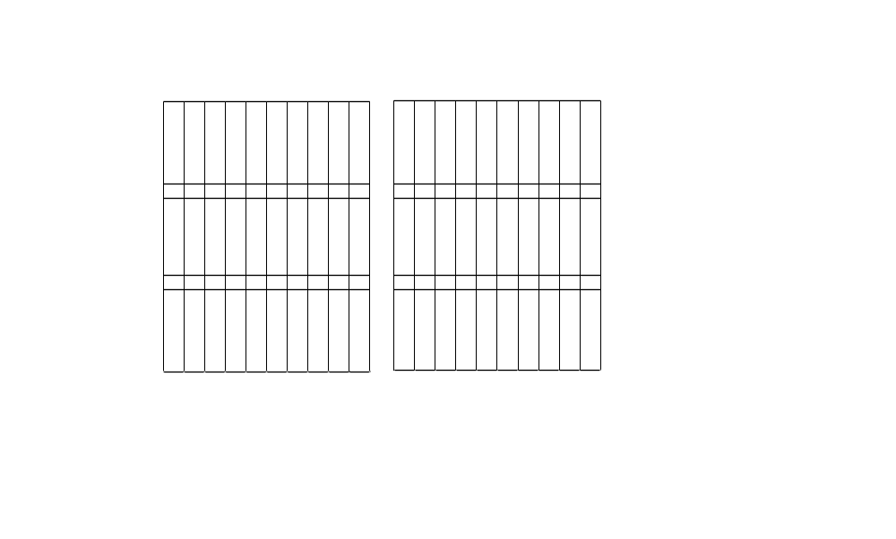
**Note 58 5/8” should be use for deck board length
58 5/8”
- USE 2 PCS OF SCRAP WOOD PER SECTION AND JOIN DECKING TO THEM WITH WOOD SCREWS MAKING SURE NOT TO PENETRATE TO THE GOOD FACE.

- FLIP SECTIONS OVER AND ENJOY.

WARRANTY

AFP INDUSTRIES WARRANTY THEIR ALUMINUM DOCKS FOR A PERIOD OF 5 YEARS.
THIS WARRANTY APPLIES UNDER NORMAL CONDITIONS AND USE OF OUR PRODUCTS.
DURING THE WARRANTY PERIOD, AFP INDUSTRIES WILL REPLACE DEFECTIVE PARTS UPON RETURN TO OUR FACTORY IN SCARBOROUGH, ONTARIO. ALL SHIPPING COSTS TO BE INCURRED BY THE CUSTOMER.
THIS WARRANTY DOES NOT APPLY TO IMPROPERLY USED OR ASSEMBLED PRODUCTS OR ACCIDENTIAL DAMAGE.
THIS WARRANTY SHALL BE DEEMED VOID IF NON-APPROVED PRODUCTS ARE ATTACHED TO THE STRUCTURE.
DAMAGE CAUSED BY FACTORS BEYOND OUR CONTROL (WEATHER, BOATS, ETC.) ARE NOT COVERED

LIABILITIES

UNDER NO CIRCUMSTANCES SHALL AFP INDUSTRIES BE LIABLE FOR DAMAGES THAT EXCEED THE AMOUNT PAID FOR THE PRODUCT OR SERVICE. THIS PROVISION INCLUDES, WITHOUT LIMITATION, ANY LIABILITY FOR CONSEQUENTIAL, SPECIAL, INCIDENTAL, INDIRECT OR SIMILAR DAMAGES. YOU AGREE THAT THE LIABILITY OF AFP INDUSTRIES ENDS WITH THE ASSEMBLY OF THE PRODUCT.

